**Name:** LEI LI 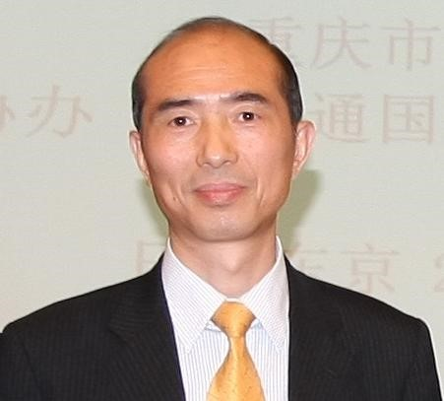 **Organization:** Hosei University **Country:** Japan

**Biography:**Lei Li, Professor and Former Dean, Faculty of Science and Engineering, Hosei University, Tokyo, Japan. Professor Li received his Doctor Degree of Science from Xi’an Jiaotong University, China in 1989, and Doctor Degree of Engineering from Tohoku University, Japan in 1994 separately. He studied at Hirosaki University, Japan as a Post Doctoral and Research Assistant from April, 1989 to March 1992. From April 1992 up to present, he has been on the Faculty of Computer Science and Engineering [1992-1997: Associate Professor, Aomori University, Japan, 1997-2001: Associate Professor, Yamaguchi University, Japan, 1999-2000: Visiting Professor, State University of New York at Stony Brook, 2002-present, Professor, Hosei University, Japan]. His research interest includes the Fast Algorithms, Parallel Algorithms, Genetic Algorithms, Neural Networks, Machine Learning Algorithms and application etc. He has published around 250 papers in refereed journals, conference proceedings and book chapters in these areas. He has been involved in more than 50 conferences and workshops as a program/general/organizing chair or advisory committee member. He is serving as the president of International Information Institute and the Editor-in-Chief of Information, An International Interdisciplinary Journal and also as an Associate Editor for some other International Journals. He has been acting as an author/co-author or an editor/co-editor of 24 books. He received HITACHI TO Software Papers International Award in Sendai, Japan in 1990, Outstanding Leadership Award from the International Conference on Computer Convergence Technology in Seoul, Korea in 2011 and Outstanding Service Award from ACM Research in Applied Computation Symposium in Miami, USA in 2011 separately.

**Personal Contact Details:**

**Email: lilei@hosei.ac.jp**